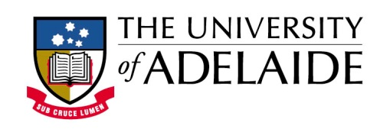

Department of History, School of Humanities
Seminar Series – Semester 2, 2016

Jennifer Clark with Tom Buchanan, Gareth Pritchard and Paul Sendziuk

‘A different research/teaching nexus in History: the scholarship of teaching and learning’

The Australian university sector has undergone dramatic change since the Bradley Review of Higher Education in 2008. One such change is the introduction of discipline standards as a result of the ALTC (Australian Learning and Teaching Council, then Office of Learning and Teaching) LTAS project (Learning and Teaching Academic Standards project). History was one of the first disciplines to devise and confirm discipline standards. Since then the history discipline has been at the forefront of discussing the ramifications of teaching to discipline standards in higher education in Australia.
In this presentation four colleagues from the University of Adelaide will talk about their contributions to a new research project which examines the teaching of history in Australian universities within the context of international developments and uses the discipline standards as an organisational framework. The presentation will discuss the value of working within the scholarship of teaching and learning and show how we might use our research skills to explore teaching in a way that helps our collective practice to be more informed and more evidence based.

Jennifer Clark has taught history for over twenty years. Her research covers American and Australian History, memorial culture and the scholarship of teaching and learning. Her most recent book is The American Idea of England: transatlantic writing 1776-1840. She is the recipient of the Vice Chancellor's Award for Excellence in Teaching (UNE) and a Carrick citation for 'Outstanding Contributions to Student Learning.' She was the 2015 Redmond Barry Fellow at the State Library of Victoria and the University of Melbourne. She is currently Head of the School of Humanities at the University of Adelaide.

Tom Buchanan teaches American and global history at the University of Adelaide. He previously taught in universities in the United States. Tom has published on the history of capitalism in the context of nineteenth-century American slavery. He is currently researching the culture of capitalism in the twentieth and twenty-first centuries via the multinational company B.H.P. Billiton, Inc. His research and practical interests in learning and teaching include historical role immersion games, game design and large group teaching.

Gareth Pritchard teaches history at the University of Adelaide. He previously taught in universities in New Zealand and the UK. He currently offers undergraduate courses on Memory Wars in Contemporary Global Conflicts, Russia in War and Revolution, and Medieval History. He is the author of two monographs: The Making of the GDR (Manchester University Press, 2004) and Niemandsland: A History of Unoccupied Germany, 1944-45 (Cambridge University Press, 2012). Together with his colleague Vesna Drapac, he will shortly be publishing a book on Resistance and Collaboration in Hitler’s Europe (Palgrave, forthcoming).

Paul Sendziuk has taught Australian and migration history at the University of Adelaide for more than 10 years, and writes on a broad range of topics including the practice of learning and teaching. In 2009 he was awarded the University’s highest teaching honour, the Stephen Cole the Elder Excellence in Teaching Award, and in 2011 received a national award from the Australian Learning & Teaching Council for ‘Outstanding Contribution to Student Learning’.

Friday 16 September
12pm noon
Stretton Room, Napier 420
ALL WELCOME

