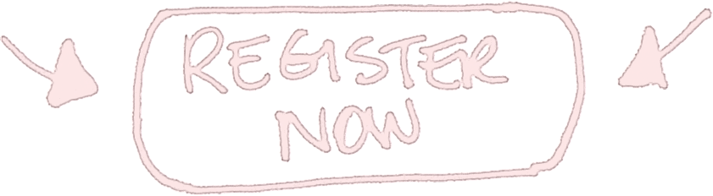

**Don’t forget**

**via your email invitation**

**FRIDAY**

**MARCH**

3pm-5pm

**20**

Join us on the Barr Smith Lawns to celebrate becoming a

**Faculty of Health Sciences Student**

Faculty of Health Sciences

International Student Welcome

**BBQ  Music  Games**