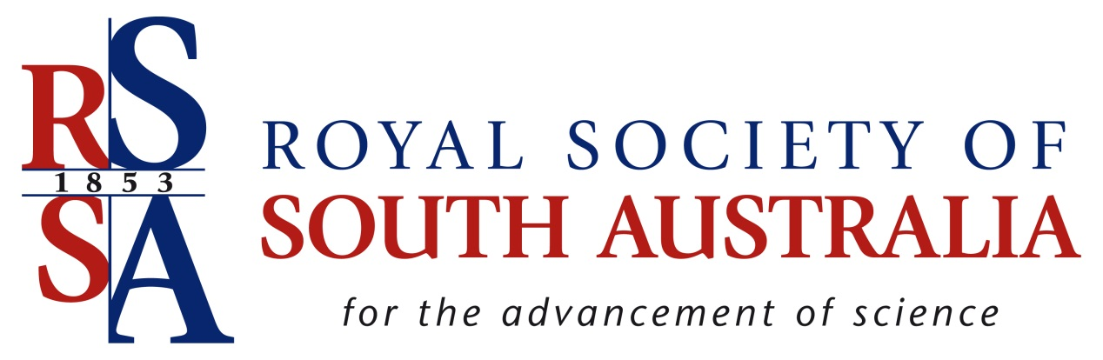

RSSA Small Research Grants Scheme

2019

Information
Rules
Instructions for Applicants
Application Form
Membership Nomination Form

Information
Background: The Royal Society of South Australia (RSSA) supports and promotes scientific research through publications, forums, and regular seminars. Starting as the Adelaide Philosophical Society in 1853, it received royal patronage in 1880, becoming the Royal Society of South Australia. It is one of the nation’s oldest scientific bodies. Its offices and meeting rooms are adjacent to the South Australian Museum’s Natural Science building.
The interests of Society members are centred largely on life sciences, earth sciences and anthropology. However, people with interests in other scientific fields are most welcome. Further information on the Society, its annual meeting program and publications are available at the following site: http://www.rssa.org.au.
In 2019, RSSA will be awarding small grants for research work in the following fields: ecology, botany, zoology, geology, geomorphology, palaeontology, geophysics, anthropology, biophysics, soil science, environmental science, environmental remediation, and archeology.
The aim of the scheme is to promote high quality natural history research that is unlikely to be funded through larger nationally competitive schemes.
Number and size of grants available: The RSSA Council has approved a maximum total of $15000 for research grants in 2019. Each applicant may apply for funding up to $2500. The number of grants awarded will depend on the quality of the applications and the budgets requested.
Important dates:
Applications close: Jun 14th, 2019.
Applicants notified of outcome: early July 2019.
Rules
1. The Primary Applicant must be a member of the RSSA for 2019 (other named applicants do not have to be members). If the applicant is a student member of the RSSA, one of their supervisors must also be a member of the RSSA.
2. The Primary Applicant can only submit one application for funding. Grant recipients from within the past 5 years are ineligible.
3. The funding request should be for a standalone research project. This research project may be part of an existing funded research programme.
4. The grant is paid as a single instalment.
5. RSSA is to be acknowledged as a funding provider in all presentations and publications arising from the supported research..
6. Recipients are to give an oral presentation to an Ordinary General Meeting of the society within 18 months of being awarded the grant. Recipients are strongly encouraged to submit project findings for publication in the Transactions of the Royal Society of South Australia.
7. Research with direct commercial application will not be supported.
8. Research involving humans or animals must be approved by a relevant institutional research ethics committee.
9. If the research is not carried out within two years of the funding being awarded it is to be returned to the Society. Funds are non-transferrable to other research projects.

Instructions for Applicants
1. Complete the Application form using software compatible with Microsoft Word. Applications should be emailed to the RSSA Secretary (roysocsa@gmail.com) with the subject: ‘RSSAGrantApp2019’.
The Application form should be saved with the following file name:
RSSAGrantApp2019 applicant surname
2. Specific instructions for completing the Application Form are as follows:
Title: A brief, descriptive title of no more than 100 characters should be provided.
Applicant details: Provide names, postal and email addresses, qualifications, and institutional affiliations (if any) for all applicants. The Primary Applicant should be listed first.
RSSA Status: Please confirm you are a member of the RSSA and if you are a student member, please name your RSSA member supervisor.
Summary: A summary of no more than 100 words should be provided. Language and terms used should be clear to Society members and to the broader public.
Project objectives: List project objectives and/or hypotheses to be tested for the research.
Methodology: Briefly (200 words maximum), describe the method(s) to be employed, along with a proposed timeline for the research project.
Likely outcomes: In no more than 100 words, describe likely project outcomes and/or findings and why these will be significant.
Budget: A budget must be provided wherein items are costed realistically for the project. The total costs of the project should be identified, available funds and in-kind resources identified, and how the RSSA funds will be spent clearly outlined.
RSSA Small Research Grants Scheme Application Form
1. Project title (100 characters max)

2. Applicant name and address (Primary applicant listed first)

3. Applicant RSSA status (and supervisor RSSA status if Student applicant)

4. Summary (100 words max)

5. Project objectives (200 words max)

6. Methodology (200 words max).

7. Likely outcomes (100 words max)

8. Project Budget
Provide details of;
a) the resources already available to the Project.
b) the funds requested from the RSSA and a detailed justification for the projected expenses.

Date of lodgement: ____________________________
RSSA use only: Received by ____________; Sent to committee chair: ___________;
RSSA membership check _____________; Filed for assessment ________________
Checklist:
- Application certified.
- All mandatory sections completed.
- Non-RSSA members – membership application completed and attached.
THE ROYAL SOCIETY OF SOUTH AUSTRALIA Inc
For the Advancement of Science
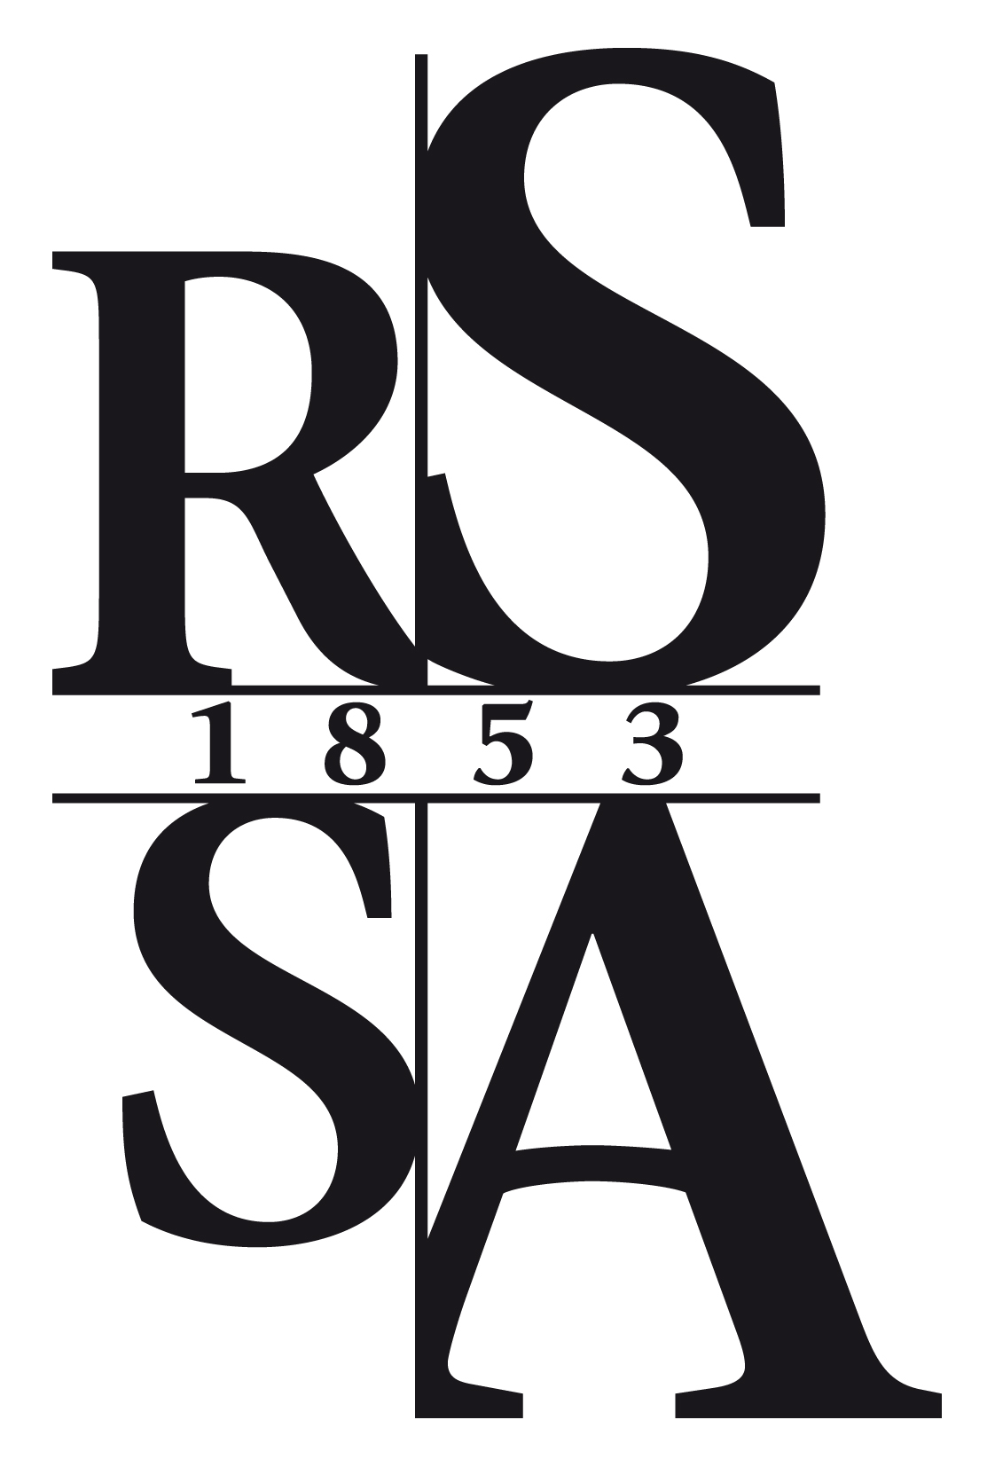

Nomination for Membership

To: Membership Secretary, The Royal Society of South Australia Inc.
c/o The South Australian Museum, North Terrace, Adelaide, South Australia 5000 Phone 08 82077590
email: roysocsa@gmail.com

I hereby nominate
Title Given names Family name
Of

Postcode
Phone: (W) (H) Fax:
Email:
as Fellow Student member Associate member (no Journal)
(please tick one box)
of the Royal Society of South Australia Inc.
The interests of the candidate. (A short curriculum vitae or resume may be attached).

Nominated by:
(nominating member's name printed)
date:
(nominating member's signature)
Seconded by:
(nominating member's name printed)
date:
(nominating member's signature)

At least one of the two members should have a personal knowledge of the candidate
The nominator and/or seconder are encouraged to introduce the candidate to their colleagues at a monthly meeting of the Society.
Council approved: Ballot:
Notified: Secretary:

