Application Form
Linkage credits to support research using linked clinical / service data in 2019

Researcher names, titles, and schools:

Title of Project:

Brief summary of project, including likely scope of linkage (500 words maximum):

Expected timeline of project:

Has HREC approval been granted for this project?

Expected number of data sources (for linkage) – please refer to the list of available datasets

Will a separate cohort file be provided for linkage by SA NT DataLink to other datasets?

The overall expected number of participants (probably individuals whom linked data is being sought)?

Any other comments:

Please submit by 10th May 2019 to lyle.palmer@adelaide.edu.au
For further information or questions on the linked data, santdatalink@unisa.edu.au or 830 21604
Supporting people centred research | 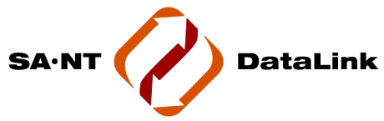 | Improving lives through data linkage

