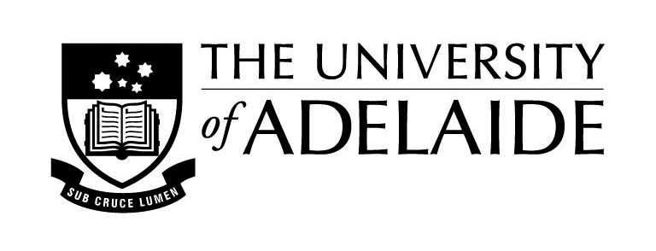
The Australian Federation of University Women SA Inc. Trust
Postdoctoral Grants 2021

Application Form

This application must be completed with reference to the Grant Rules and Application Guidelines.
A. All applicants to complete
Title and Name

Project title

Total funding request

School

Faculty

Email address

University of Adelaide Researcher Profile
Contact phone number

Current Position

Appointment type | Full time or Part time:  Continuing or Contract:
Contract end date
(if applicable)
Primary field of research

Date PhD awarded

Briefly describe the nature and length of any career disruptions
Current grants or research support funding held
Are other University of Adelaide funds available to support this activity? Provide details

B. Complete if applying for conference participation support
Conference title

Conference location and dates

Title of conference presentation or research poster
Budget (up to A$5,000) | Travel:  Registration:  Accommodation:  Other:

C. Complete if applying for other research support
Description of requested support
Budget (up to A$5,000) | Item(s):

Application detail. Please provide the following documents:
- This covering application form.
- A statement of purpose (maximum of 2 A4 pages).
- A summary curriculum vitae (maximum of 5 A4 pages).
- A letter of support from your supervisor or Head of School (maximum of 1 A4 page).

Submit your application in electronic format by 5.00pm Friday 3rd September 2021 to:

Nikki Hodge
Research Services
Email: DVCRschemes@adelaide.edu.au

